

**CAT**

**ACADEMIC YEAR: 2024-2025**

**LEVEL or CLASS: Year 2 A, B, C&D**

60

**TERM: II**

**COURSE title: Advanced networking**

**COURSE CODE: ICTSFP4001**

**NUMBER OF TEACHING HOURS/WEEK: 3**

**DATE: 24/02/2025**

**DURATION: 90Minutes**

**MAXIMUM MARKS: 60**

**INSTRUCTIONS:**

* **Provide your answers to this question paper.**
* **This exam consists of two (2) PARTs, Part I has 15 questions, Part II has 2 questions and all questions are compulsory**

**STUDENT IDENTIFICATION**

**Student name: ………………………………………………………………………**

**Class: …………………………………………………………………………………**

**PART I: Provide the correct answer (2 marks for each)**

1. You are designing a network for a company with three departments: HR, Finance, and IT. Each department needs to be isolated from the others for security reasons. Which of the following is the most efficient way to achieve this isolation?

A) Use separate physical switches for each department.

B) Create a single VLAN for all departments and use firewalls to filter traffic.

C) Create separate VLANs for each department on the same switch.

D) Use a hub to connect all departments and rely on MAC address filtering.

1. You are configuring a trunk link between two switches that will carry traffic for multiple VLANs. Which of the following protocols is commonly used for VLAN tagging on trunk links?

A) STP (Spanning Tree Protocol)

B) VTP (VLAN Trunking Protocol)

C) 802.1Q

D) RIP (Routing Information Protocol)

1. You need to enable communication between devices in different VLANs. Which of the following devices is required to enable inter-VLAN routing?

A) A Layer 2 switch

B) A router or Layer 3 switch

C) A hub

D) A bridge

1. You are troubleshooting a network issue where devices in different VLANs are unexpectedly receiving each other's traffic.

Which of the following could be the most likely cause of this issue?

A) The native VLAN on the trunk link is mismatched between switches.

B) The switches are running different versions of the VTP protocol.

C) The STP protocol is blocking the wrong port.

D) The VLANs are not assigned to any access ports.

1. How many broadcast domains are shown on the below network diagram?

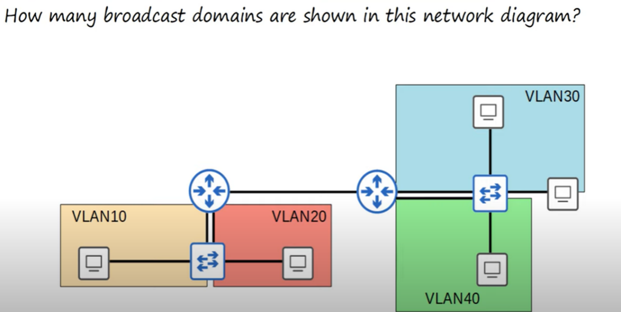

1. Four (4) broadcast domain
2. Five (5) broadcast domains
3. Two (2) broadcast domains
4. Six (6) broadcast domains
5. What happens if you try to assign a switch interface to a VLAN that doesn’t exist?
   1. The command will fail
   2. The switch will create the VLAN.
   3. The interface will be disabled until you create the VLAN
   4. All VLANs exist by default
6. Which TWO answers are valid options to configure the native VLAN on a router in a ROAS configuration? (select the two best answers, each answer is a complete solution)

a) R1(config-if)# encapsulation dot1q 112

R1(config-if)# ip address 192.168.1.1 255.255.255.0

b) R1(config-subif)# encapsulation dot1q 112 native

R1(config-subif)# ip address 192.168.1.1 255.255.255.0

c) R1(config-if)# ip address 192.168.1.1 255.255.255.0

d) R1(config-subif)# switchport trunk native vlan 112

R1(config-subif)# in address 192.168.1.1 255.255.255.0

1. During the configurations of IP routing on a LAN sub-interface, the following error was displayed:

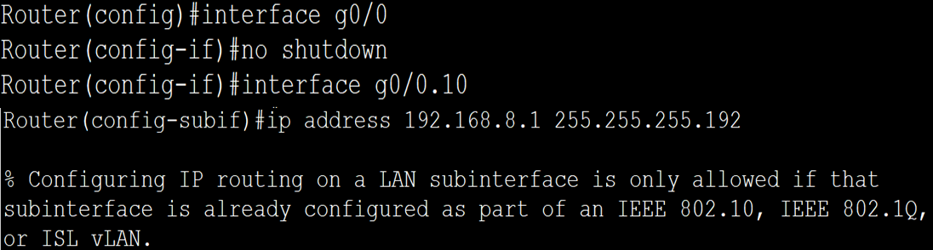

What is the cause of this error message?

**Answer: No encapsulation**

…………………………………………………………………………………………………………………………………………………………………………………………………………………………………

1. You issue the following commands on Catalyst 2950 switch:

* Switch(config)#interface FastEthernet 0/7
* Switch(config-if)#switchport trunk encapsulation dot1q
* Switch(config-if)#switchport mode trunk
* Switch(config-if)#switchport trunk native vlan 44

Which of the following statements is true regarding VLAN traffic when it is sent over port FastEthernet 0/7 (Select the best answer)

* 1. VLAN 1 traffic will be untagged
  2. VLAN 44 traffic will be untagged
  3. All VLAN traffic will be tagged
  4. All VLAN traffic will be untagged

1. You are configuring a trunk port, but you want to restrict it to carrying traffic for only specific VLANs 10,15,20,30.

Which of the following commands would you use to restrict VLANs on a trunk port?

A) switchport mode trunk

B) switchport trunk allowed vlan 10,15,20,30

C) switchport access vlan 10,15,20,30

D) switchport native vlan 10,15,20,30

1. You are configuring a trunk link between a Cisco switch and a non-Cisco switch.

Which of the following statements is true regarding the Native VLAN and trunking protocols?

A) The Native VLAN must be VLAN 1 when using 802.1Q.

B) The Native VLAN must be the same on both ends of the trunk link.

C) The Native VLAN is not supported when using ISL (Inter-Switch Link).

D) The Native VLAN is automatically negotiated between switches.

1. You are configuring a link between two switches that will carry traffic for multiple VLANs.

Which type of port should you configure, and how is VLAN traffic handled on this port?

A) Access Port - Untagged traffic for a single VLAN.

B) Trunk Port - Tagged traffic for multiple VLANs.

C) Access Port - Tagged traffic for multiple VLANs.

D) Trunk Port - Untagged traffic for a single VLAN.

1. You notice that broadcast traffic is causing performance issues on your network.

How can VLANs help improve network performance?

A) By increasing the bandwidth available to each device.

B) By reducing the size of broadcast domains.

C) By encrypting broadcast traffic.

D) By providing redundant paths for traffic.

1. You need to allow communication between devices in the Sales VLAN and the IT VLAN.

Which of the following devices is required to enable this communication?

A) A Layer 2 switch

B) A router or Layer 3 switch

C) A hub

D) A bridge

1. You want to assign a switch port (e.g., GigabitEthernet 0/1) to VLAN 10.

Which of the following commands is used to assign the port to VLAN 10?

A) switchport access vlan 10

B) vlan 10

C) port vlan 10

D) switchport mode access vlan 10

1. You want to change the Native VLAN on a switch trunk port to VLAN 99 for security reasons.

Which of the following commands is used to configure the Native VLAN on a trunk port?

A) switchport native vlan 99

B) switchport trunk native vlan 99

C) switchport mode native 99

D) vlan native 99

1. You need to configure a Layer 3 switch to enable communication between VLANs 10 and 20.

Which of the following commands is used to configure inter-VLAN routing on a Layer 3 switch?

A) interface vlan 10 and interface vlan 20, then assign IP addresses to each VLAN interface.

B) vlan routing 10 and vlan routing 20

C) switchport mode trunk on all ports.

D) ip routing and vlan routing enable

1. You are configuring a switch to participate in a VTP domain but do not want it to make changes to the VLAN database.

Which VTP mode should you configure on this switch?

A) Server Mode

B) Client Mode

C) Transparent Mode

D) Off Mode

1. You want to reduce unnecessary traffic on trunk links in your network.

Which VTP feature can help achieve this goal?

A) VTP Server Mode

B) VTP Transparent Mode

C) VTP Pruning

D) VTP Version 3

1. You are troubleshooting a VTP issue where a switch has overwritten the VLAN database on other switches.

What is the most likely cause of this issue?

A) The switch had a higher VTP configuration revision number.

B) The switch was in Transparent Mode.

C) The switch had a different VTP domain name.

D) The switch had VTP Pruning enabled.

1. You accidentally deleted a VLAN on a switch in Server Mode.

What will happen to the VLAN on other switches in the VTP domain?

A) The VLAN will be deleted on all switches in the domain.

B) The VLAN will remain on other switches because they are in Client Mode.

C) The VLAN will be deleted only if VTP Pruning is enabled.

D) The VLAN will be deleted only on switches with a lower VTP revision number.

1. You are troubleshooting a network issue and notice that a switch port is in the "**Blocking**" state.

What does the "Blocking" state indicate in STP?

A) The port is forwarding traffic normally.

B) The port is disabled and not participating in STP.

C) The port is not forwarding traffic to prevent loops.

D) The port is in a transitional state before becoming active.

1. You are configuring STP on a network with multiple switches.

How is the Root Bridge elected in STP?

A) The switch with the lowest MAC address becomes the Root Bridge.

B) The switch with the highest MAC address becomes the Root Bridge.

C) The switch with the lowest Bridge ID becomes the Root Bridge.

D) The switch with the highest Bridge ID becomes the Root Bridge.

**Part II: has 3 questions (Compulsory) /20 Marks**

1. Analyze the network diagram below, which contains three different VLANs with the following IP addresses: VLAN 10: 192.168.8.0/26, VLAN 20: 192.168.8.64/26, and VLAN 30: 192.168.8.128/26. Then, answer the provided questions.

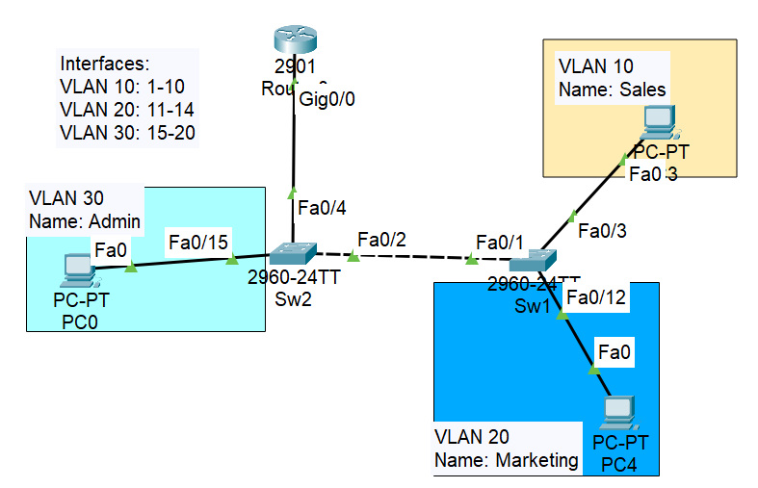

* + 1. How many interfaces can be configured as a trunk port?

**Answer: ………………………………………………….................................**

* + 1. What is the broadcast IP address of VLAN 20?

**Answer: ……………………………………………………………………….**

* + 1. What type of inter-Vlan is shown on the network diagram?

**Answer: ……………………………………………………………………….**

* + 1. Provide VLAN 10 configuration on **Sw2**

Sw2(config)#...............................................................................

Sw2(config-vlan)#......................................................................

Sw2(config-vlan)#exit

* + 1. Assign interface to VLAN 30 on switch Sw2.

Sw2(config)#...........................................................................................................

Sw2(config-if-range)#...........................................................................................

Sw2(config-if-range)#...........................................................................................

Sw2(config-if-range)#exit

* + 1. Configure sub-interface **g0/0.30** on the router to enable **inter-VLAN** routing.

Router(config)# …………………………………………………………………………………….

Router(config-subif)# …………………………………………………………………………..

Router(config-subif)#......................................................................................

Router(config-subif)#exit

1. VLAN Trunking Protocol (VTP) is a protocol that manages and synchronizes VLAN configurations across a network. It allows switches to share VLAN information, ensuring consistency and reducing manual configuration errors. It has been configured on the below network as shown. However, switches failed to synchronize VLAN configurations due to misconfigurations.

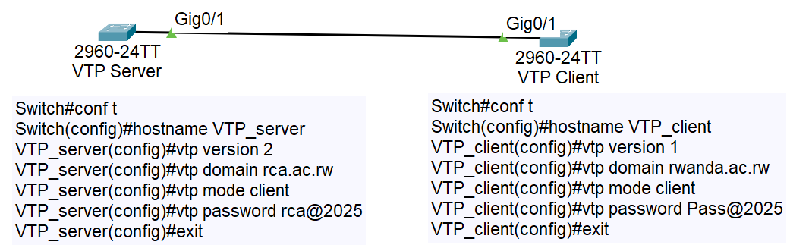 Check the VTP configurations at each switch and identify all misconfiguration.

**Answer:**

1. **………………………………………………………………………………………………………………….**
2. **………………………………………………………………………………………………………………….**
3. **…………………………………………………………………………………………………………………**
4. **…………………………………………………………………………………………………………………**
5. Refer to the network diagram below. Each of these four switches has been configured with a hostname, priority values, as well as being configured to run Rapid Spanning Tree Protocol. No other configuration changes have been made.

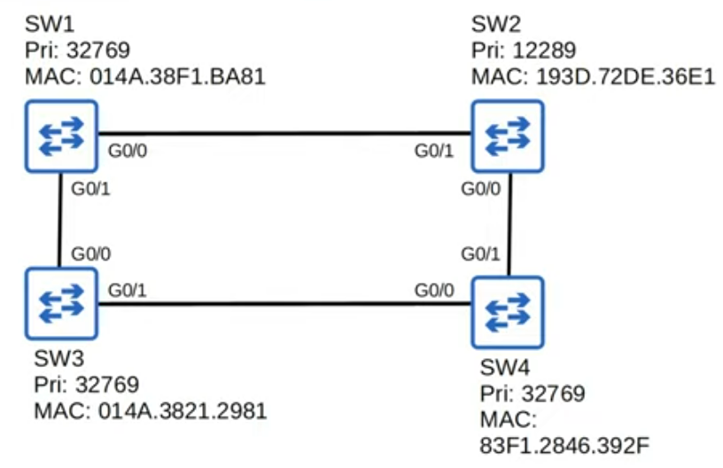

* 1. Which switch is a root bridge?

**Answer:**

* 1. Which ports on all switches are root ports, designated and non-designated ports?

**SW1: G0/0: ……………………………………………………………..**

**G0/1: ……………………………………………………………….**

**Sw2: G0/0: …………………………………………………………….**

**G0/1: ………………………………………………………………**

**Sw3: G0/0: …………………………………………………………….**

**G0/1: ……………………………………………………………….**

**Sw4: G0/0: …………………………………………………………….**

**G0/1: ……………………………………………………………….**

**Good luck**

end